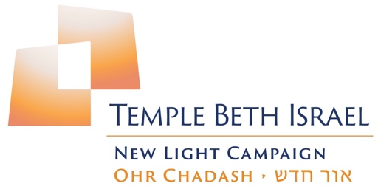

Campaign Update

Temple Beth Israel’s new Capital Campaign, Ohr Chadash (New Light), has been in a planning stage, in one form or another, for the last number of years. This period, interrupted by the pandemic, included a formal needs assessment, developing a budget framework, committee formations, and engaging experienced professionals to help formulate and guide the core planning group’s efforts. As part of that process, the decision was to formally introduce our campaign in a series of phases.
Phase One commenced in January 2024 and included gaining financial commitments from Board members, Past Presidents, and all campaign committee members. The enthusiasm and generosity shown during this phase has demonstrated both an alignment with the goals of the proposed physical renovations, but also emphasized the need we have to update our facility, which last received major work in the late 80’s, as we approach our 100th anniversary.

Phase One is now ending, and with the solid foundation for success it has created, we are soon moving into Phase Two – the introduction of the campaign to the entire TBI connected community.

As we move forward, the Tekiah! will feature numerous FAQ’s such as the ones you see below, which will include information about the goals and progress of the campaign.

FAQ’S Volume #1

- Why is TBI’s new capital campaign called Ohr Chadash?
The Hebrew words “Ohr Chadash אור חדש” translate as “new light.” Light is a central theme in Judaism. Although our congregation, clergy and staff work together continuously to inspire, support, and shed light, there is a clear need to “increase the light” focused on our buildings and campus. They need more light, more shine, and the glint of polish.

- What are the goals of the planned renovations?
Each major part of the plan is evaluated based on these criteria:
- encourage community-building by providing attractive gathering spaces
- connect inside and outside
- inspire elevated feelings of awe and sacredness during worship
- utilize the most attractive yet efficient modern design ideas and materials to create beautiful Jewish space?
- reflect the culture, history and a shared future vision for our TBI community

- What areas are being remodeled?
- Structural and design upgrades will be focused on the sanctuary, social hall, kitchen, main lobby and restrooms.

- What areas are being refreshed?
- Our meeting rooms, offices, library and TLCC classrooms will receive attractive makeovers.

- What is new?
- “New Light” will be brought into our sanctuary through creating a window opening on the east wall and modernizing the lighting in both the sanctuary and social hall
- A fully remodeled kitchen
- A gender-neutral restroom
- An added West-Side Social Hall entrance leading to a comfortable outside gathering space and reconfigured outdoor worship area;
- An updated East-Side foyer and access to a new garden space;
- An expanded lobby seating area

Look for more FAQ’s next time. Have a question? Email us at ohrchadash@tbipomona.org.

