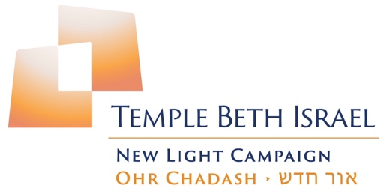

Campaign Update

OHR CHADASH CAMPAIGN
FAQ Volume #2

- Why should you “Light Up the Night” on September 14?
This will be an extraordinary night:
- To experience what our beloved temple might look like in the future.
- To learn about the construction plans and schedule.
- To learn about the campaign’s progress.
- To honor Rabbi Kupetz and Cantor Buch.
- To eat, drink, and revel in our community and our future.

- How is the safety and security of congregants being addressed in the renovation plans?
- A representative of TBI’s Security Committee is involved in looking at plans and making recommendations as a member of the Renovation Committee.
- The height and treatment of windows, the height of walls and trees, and all other security concerns are being carefully considered.
- Any earthquake mitigation planned by the Buildings and Grounds Committee and approved by the Board will occur in conjunction with the Renovation Committee.

- How are the architectural plans taking protecting the environment into account?
- Sustainability is being considered in all choices of materials and furnishings.
- All appliances in the new kitchen will be energy efficient.
- New lighting will give off less heat and provide more light.
- More landscaping and trees will help cool our environment.

- How will the plans make the campus more accessible?
- A new fire exit out to Towne Avenue will have an ADA approved railing.
- New tile floors in walkways will be skid proof.
- Care will be taken to make walking up to and leaving the bimah easier for everyone.
- New hearing assistance devices will be more effective for those congregants who need them.

- Need an answer - write to ohrchadash@tbipomona.org

